A000-ME-Mesopotamia-Sumeria-Enuma Elish Petroglyph Panel-3000 BCE

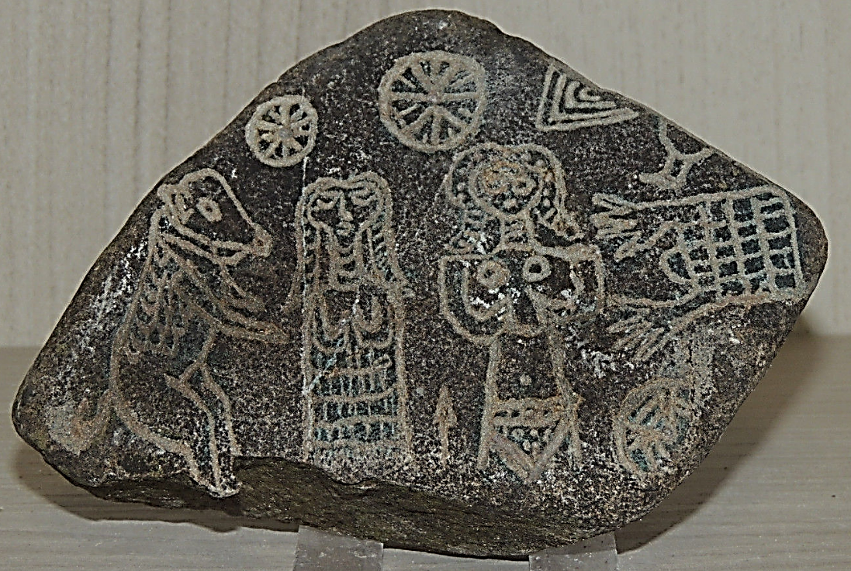

Fig. 1. ME-Mesopotamia-Sumeria-Enuma Elish-Petroglyph Panel-3000 BCE

**Case no.: 2**

**Accession Number:**

**Formal Label:** ME-Mesopotamia-Sumeria-Enuma Elish-Petroglyph Panel-3000 BCE

**Display Description:**

This petroglyph panel from the area near Sumer in southeastern Iraq. It is a story-board of the great Sumerian liturgy, Enuma Elish, embodying the myth of creation as it was current in Sumer from about the middle of the second millennium BCE. The Creator God Gilimma and his consort stand beneath the Moon and the Sun respectively. This is interesting because the Moon is usually associated with the female element and the Sun with the male. To the right of Gilimma is the first bull cattle he created. To the left of Gilimma’s consort is the holy reed house that was made possible by Gilimma who “bound the reeds in the face of the waters.”

The Ma’dan or Marsh Arabs inhabit the marshy area at the junction of the Tigris and Euphrates rivers in Iraq. They are a semi-nomadic tribal people with their own distinct culture, whose way of life has changed very little in the past couple thousand years. Their whole way of life revolves around the marshes – they live in floating houses made entirely of reeds harvested from the open water and *Qasab,* a kind of giant grass that looks like bamboo, which can grow as tall as 25 feet (7.6 meters).

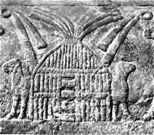 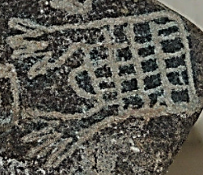 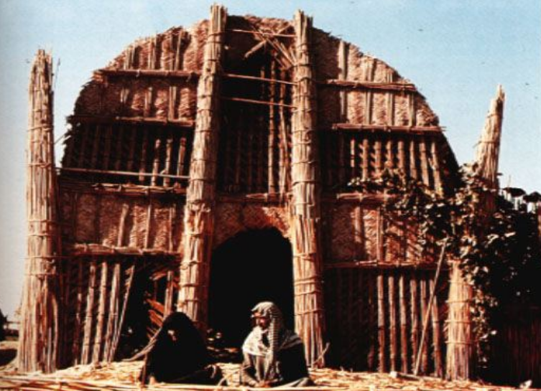

Left, petroglyph of المضيف‎ al-muḍīf, Sumeria, reed house, 3000 BCE; middle, المضيف‎ al-muḍīf on current petroglyph panel, 3000 BCE; right, المضيف‎ al-muḍīf, ca 1950.

Al-muḍīf is a traditional Arab structure constructed on marshland platforms at the confluence of the Tigris and Euphrates Rivers since 3000 BCE. This is confirmed by a petroglyph of al-muḍīf discovered at Uruk, which is now in the British Museum.

Below is an extract from the Enuma Elish creation myth:

No city had been created, no creature had been made,

Nippur had not been created, Ekur had not been built,

Erech had not been created, Eanna had not been built,

Apsû had not been created, Eridu had not been built,

Of the holy house, the house of the gods, the habitation had not been created.

All lands were sea.

At the time when a channel (was formed) in the midst of the sea,

Then was Eridu created, Esagila built,

…….

Gilimma bound reeds in the face of the waters,

He formed soil and poured it out beside the reeds.

[He]filled in a dike by the side of the sea,

[He . . .] a swamp, he formed a marsh.

[. . .], he brought into existence,

[Reeds he form]ed, trees he created.

Here the Sumerian Creator God Gilimma is pictured as forming dry reed platforms from the marshes in the primeval waters at the confluence of the Tigris and Euphrates Rivers in much the same way as the al-muḍīfs are created by the Ma’dan or Marsh Arabs today. All the world was sea until the Creator God Gilimma created land out of the waters by the only practical method that was possible in Mesopotamia. This rôle was then usurped by the patron god of Eridu, Enki.

[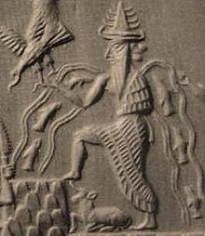](https://en.wikipedia.org/wiki/File:Enki(Ea).jpg)

Detail of Enki from the Adda Seal, an ancient Akkadian cylinder seal dating to circa 2300 BCE. After https://upload.wikimedia.org/wikipedia/commons/8/87/Enki%28Ea%29.jpg

The mention of Eridu in the Enuma Elish is extremely important as it places a date and a geographical location where the first al-muḍīfs were built at 3000 BCE, at the then confluence of the Tigris and Euphrates Rivers 12 km southwest of [Ur](https://en.wikipedia.org/wiki/Ur). Eridu was originally an intimate conglomeration of temple cities, all made of mud brick and all built on top of one another. As the temples expanded skyward cities expanded outward and al-muḍīfs were built in the marshes that interconnected with each other. Thus a common Sumerian mythology was born of daily social interaction. Originally, Eriduans selected Enki as their mythic hero, who was probably a revered ancestor known for knowledge (gestú) of water, crafts (gašam), and creation (nudimmud), perhaps, of the first al-muḍīf.

**LC Classification: BS1236**

**Date or Time Horizon:** 3000 BCE

**Geographical Area:** Eridu

**Map:**

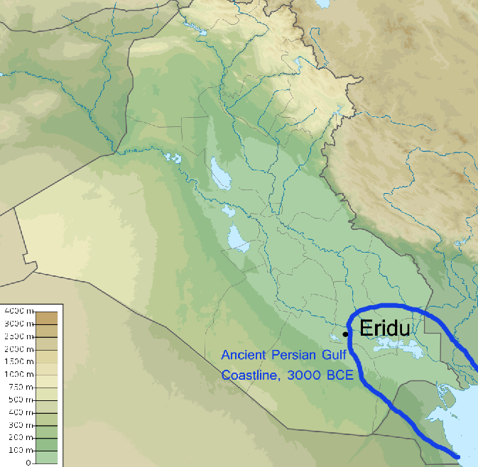

**GPS coordinates:** [30°49′1″N 45°59′45″E](https://tools.wmflabs.org/geohack/geohack.php?pagename=Eridu&params=30_49_1_N_45_59_45_E_)

**Cultural Affiliation:** Sumerians

**Medium:** stone

**Dimensions:** 4 x 5 in

**Weight: 1 lb**

**Condition: original**

**Provenance:** old French collection

**Discussion:**



A view of المضيف‎ al-muḍīf of the descendants of the Sumerians of 2000 BCE ca 1980, the Marsh Arabs (Arabic: عرب الأهوار‎ ʻArab al-Ahwār "Arabs of the Marshlands") or Maʻdān (Arabic: معدان‎ "dweller in the plains"). After https://cdn.zmescience.com/wp-content/uploads/2014/12/850x556xparadiselost.jpg.pagespeed.ic_.H8CBG_KhtP1vmJECJ7VN.jpg

**References:**

Broadbent, G., "The Ecology of the Mudhif," in: Geoffrey Broadbent and C. A. Brebbia. 2008. Eco-architecture II: Harmonisation Between Architecture and Nature. WIT Press.

King, Leonard W. 2010. Legends of Babylon and Egypt in Relation to Hebrew Tradition. New York: Cosimo Classics.

Ochsenschlager, E.L.. 2004. Iraq's Marsh Arabs in the Garden of Eden. Philadelphia: University of Pennsylvania Press.